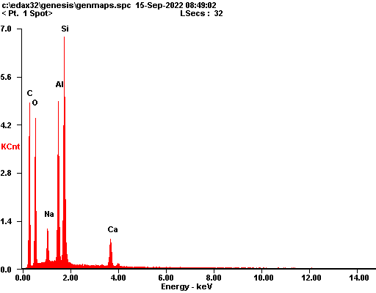

|  |  |  |
| --- | --- | --- |
| ***Element*** | ***Wt%*** | ***At%*** |
| ***CK*** | 40.87 | 55.23 |
| ***OK*** | 24.62 | 24.98 |
| ***NaK*** | 02.81 | 01.99 |
| ***AlK*** | 10.55 | 06.35 |
| ***SiK*** | 16.71 | 09.66 |
| ***CaK*** | 04.44 | 01.80 |
| ***Matrix*** | Correction | ZAF |

